**REACT ASSIGNMENT**

Module – 4 (List And Hooks)

1. Explain Life cycle in Class Component and functional component with Hooks.

Ans. A React component undergoes three different phases in its lifecycle, including mounting, updating, and unmounting. Each phase has specific methods responsible for a particular stage in a component's lifecycle.

**Class Components**

Class components have a series of lifecycle methods that are executed at different points in the component's life.

1. Mounting Phase:

* constructor(): The constructor is called when the component is created. It's used for initializing state and binding event handlers.
* render(): This method is required and is responsible for rendering the component.
* componentDidMount(): Invoked after the component is mounted to the DOM. It's a good place to perform network requests or set up subscriptions.

2. Updating Phase:

* shouldComponentUpdate(nextProps, nextState): Returns a boolean indicating whether the component should re-render. It helps optimize performance.
* render(): Re-renders the component.
* componentDidUpdate(prevProps, prevState): Invoked after the component is updated.

3. Unmounting Phase:

* componentWillUnmount(): Invoked just before the component is unmounted and destroyed. Used for cleanup operations, like canceling network requests or clearing subscriptions.

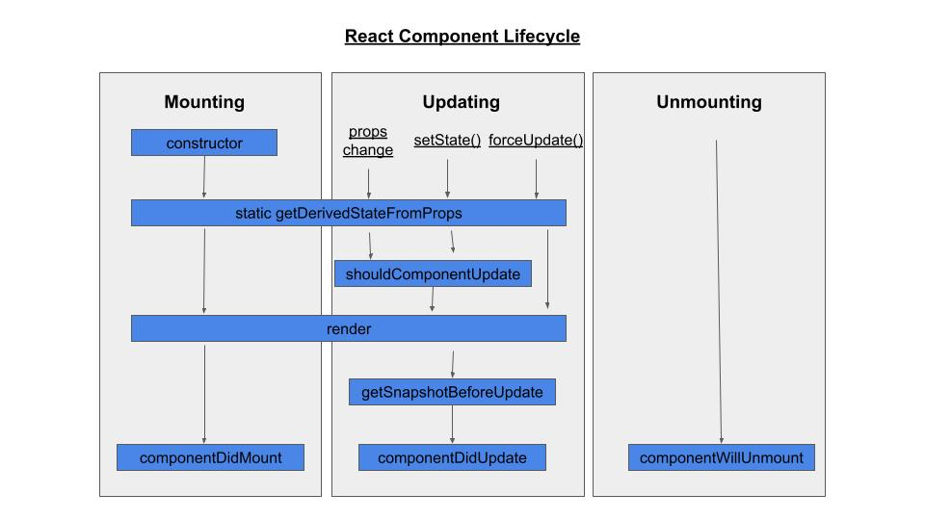

**Functional Components**

1.Mounting and Updating:

useState(): Allows functional components to manage state.

useEffect(): Takes a function that contains code with side effects. It's analogous to componentDidMount, componentDidUpdate, and componentWillUnmount combined.

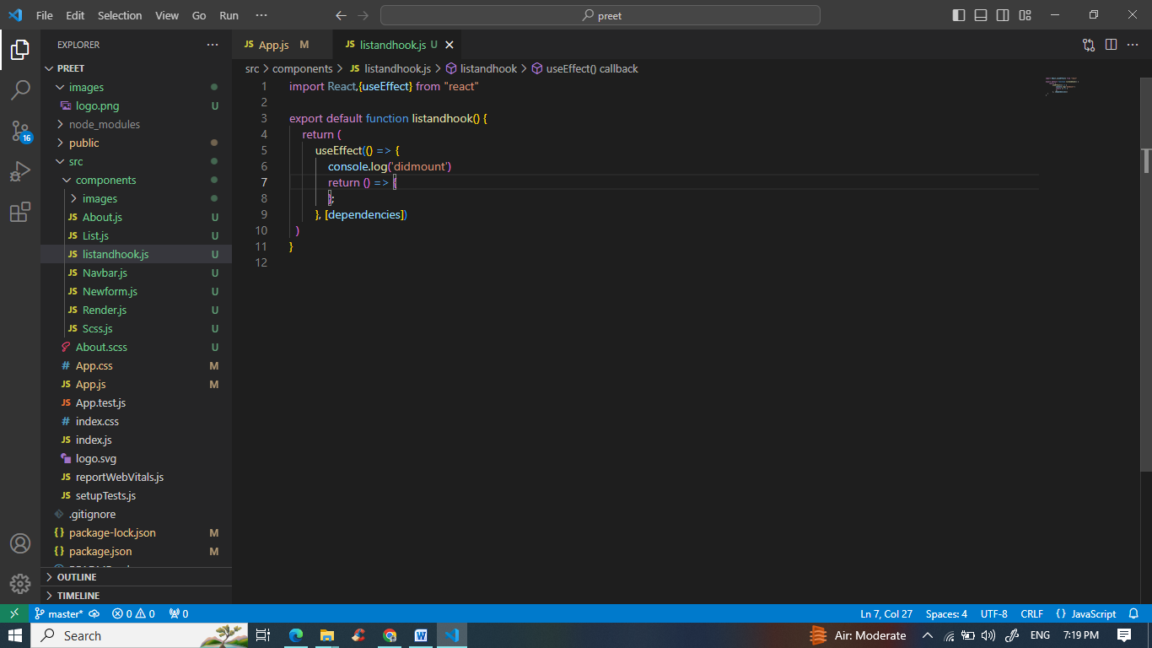

Unmounting:

The cleanup code in useEffect serves the purpose of

componentWillUnmount

**Class components**

React Class components have a built-in state object. You might have noticed that we used state earlier in the component constructor section. The state object is where you store property values that belongs to the component

